**Task 6 - Build Your Brand 01 - Career Goals**

Answers by Joanna Symonowicz

**Practical Task 1**

With *HyperionDev*, I am currently enrolled in the Skills Bootcamp in Data Science (Fundamentals). This program equips me with the ability to utilize Python for data analysis and constructing machine learning models. The skills acquired through this bootcamp present an array of lucrative self-employment prospects, particularly in today's data-centric landscape.

A noticeable trend exists in the demand for statistical data analysis among researchers in medicine and biology. Many professionals in these fields lack expertise in mathematics and statistical analysis, presenting a prime opportunity. Alongside my role desired full-time employment as a data scientist, I aspire to establish myself as a self-employed consultant catering to biologists' statistical analysis needs. I hope that this initial idea will evolve based on the market demand.

**Practical Task 2**

I am in a **JOB SEEKER**.

Role 1

* Job title: Quantitative Researcher (Data Science/Machine Learning/Mathematical Modelling)
* Company: G-Research
* Company size: 501-1,000 employees
* Location: London
* Job vacancy URL: <https://www.gresearch.com/role/R2269-Quantitative-Researcher/>
* Lead Talent Acquisition Specialist: Oliva Bateman
  + E-mail: [recruitmentteam@gresearch.com](mailto:recruitmentteam@gresearch.com), [Oliva.Bateman@gresearch.co.uk](mailto:Oliva.Bateman@gresearch.co.uk)
  + LinkedIn profile URL: <https://www.linkedin.com/in/olivabateman/>

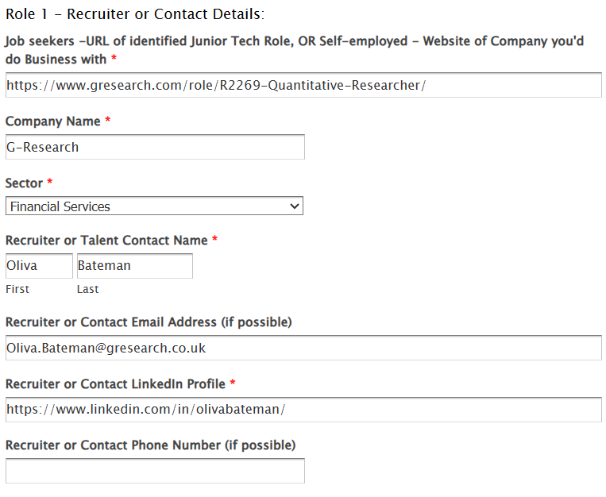

Role 2

* Job title: Data Scientist
* Company: Point72
* Company size: 1,001-5,000 employees
* Location: London
* Job vacancy URL: <https://careers.point72.com/CSJobDetail?jobName=data-analyst&jobCode=CSS-0009070&retURL=/CSCareerSearch>
* Recruiter: Diana Barenfeld
  + E-mail: [diana.barenfeld@point72.com](mailto:diana.barenfeld@point72.com)
  + LinkedIn profile URL: <https://www.linkedin.com/in/dianabarenfeld/>

